CP3407- Advanced Software Engineering

Abdalnasser Zamara  
Alex Carlos Silva  
Heylon White   
Jacob Negri

ITERATION-1 OF AGILE SOFTWARE DEVELOPMENT

Initial project specifications including goals, deliverables, and planning for iteration-2

Contents

Project Scope 2

Justification 2

Scope 2

Deliverables and Milestones 3

Limits and Exclusions 3

Project Team 5

Agile Positions 5

Product Owner 5

Scrum Master 5

Development Team 5

Contributions 5

Abdalnasser Zamara 5

Alex Carlos Silva 5

Heylon White 5

Jacob Negri 5

# Project Scope

## Justification

Weather forecasts are developed by using current atmospheric data such as the temperature, humidity and wind conditions and previously studied atmospheric understanding to deliver a future weather forecast. The National Weather Service wishes to collect information from remote areas to help with weather forecasting, forecast accuracy assessment and climate change modelling.

The main method for data collection used on hard to reach sites has been manual ie, by sending people to those remote stations and have them collect the data manually. This method has proved to be very expensive and very time consuming. Some areas that are hard to reach did not have weather forecasts, making for an expensive inefficient method.

Recent advances in sensors and micro controls have allowed for the development of remote automatic collection systems. These systems are connected to a border weather information system and work individually without regular supervision to collect and send the required data to right person in his or her office.

## Scope

A weather station is a device that collects data related to the weather and the environments surrounding it, using an array of advanced sensors. This weather station will be capable of set specifications such as windspeed condition range and wind direction, humidity, air pressure, all while being able to function without an external energy source. This means that the weather forecast station needs to be able to harness the power from its surroundings such as; solar panels, wind turbines and/or a water turbine all based on the most effective method relative to the location.

The control of this device will be done via an embedded system, which is a combination of computer and software that can be programmable and is designed for this specific device. The device will have the capability of collecting/ gathering the required data and sending it to the required personal via satellite communication and while also keeping a back up of this data, if satellite coverage does not exist in that area.

This project requires the stations’ interface design and implementation, as well as the background calculations of the data which will be done by the respective sensors. For example, a humidity sensor is required to collect and gather the humidity information of the site, and so are the rain sensors, temperature sensors and the wind sensors.

The Graphical User Interface (GUI) for this weather station simulation which will be undertaken, is to be implemented using any coding language. The most relevant and appropriate software was found to be **BALSAMIQ.** Balsamiq is a wireframing tool that helps for a fast and efficient reproduction/ sketch of the, to be made software, graphical interface. The choice of simulation software also offers an easy detailed design that can be quickly shared online which is a major requirement for this project. Github was also utilised throughout this group project for its great cloud sharing benefits such as the sharing of all project documentation and programmed code.

Some back up features that are to be developed within this weather station are such as; data backup onto an available hard drive housed within the weather station. Secondly, a continuous monitor and upload type of system that allows the data to be monitored when required to ensure correct functionality of the station. Also, the station will have at least one external power source as expressed earlier as well as a battery that can last the station for weeks at a time in case of damage to those external power sources.

Thus, the two main features of this station will be;

1. The Green external power source which is backed up be a battery that is rechargeable via that power source, making the system completely autonomous.
2. The continuous backup and upload of all the data to ensure the correct data is being obtained.

## Deliverables and Milestones

To ensure the success of this project, the outline of the final deliverables are:

1. An executable file, that opens a window which houses an emulation of the designed weather station interface and functionality.
2. A final report attached with this executable discussing the file/station.

To ensure full functionality and operation of the system, a set of predetermined date that simulates the data to be collected, which will be loaded onto the executable file/ Graphical interface and the designed emulator will be tested for robustness and the viability and workings of all features.

A set of expected milestones for this project have been shown in figure 1. The Gantt shows all the tasks that require completion, the duration of each task and the expected finish date.

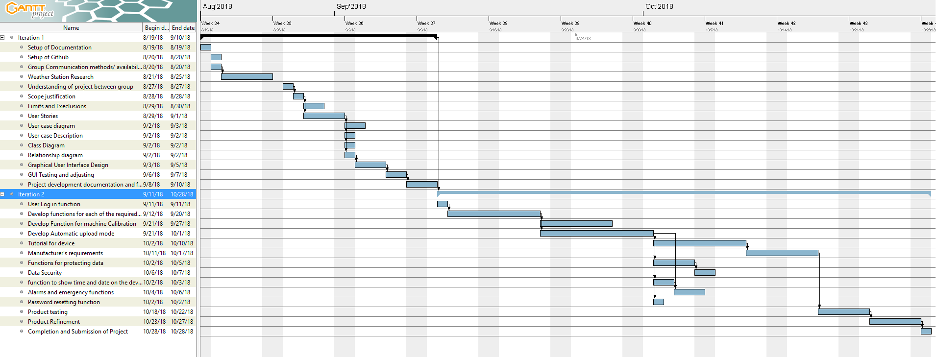

## Limits and Exclusions

The Limits and Exclusions of this weather station project extend to it being completely 100% digital, meaning everything including the data used will be virtually simulated and hypothetical. No physical hardware will be manufactured and implemented, and any problems caused by the physical hardware side have not been considered throughout this project.

# Project Team

## Agile Positions

### Product Owner

Abdalnasser Zamara was nominated as the main product owner due to his familiarity with the weather station project and his communication input in the team. The Product Owner is responsible for maximizing the value of the product. Thus, a product owner represents all stakeholders and the any requirements and concerns that arise from stakeholder’s perspective and from the customers perspective.

A product owner becomes the voice of concern of the costumers, meaning he or she will focus on the development of the weather station and ensure that all deadlines and milestones are met to maximise return.

### Scrum Master

Jacob Negri was elected by the group as the scrum master. His main role will be as advisor to other team members throughout development. A scrum master is known as the facilitator for an agile development team.

He allows the team to stay organised and ensures that when problems arise that they are dealt with smoothly and changes are done quickly and in accordance with agile principles. Jacob was elected for this role as he understand the amount of time and effort required to carry out the proposed features of the weather station and he will ensure that the development team deliver a successful project.

### Development Team

The development team will be lead by Alex Carlos Silva and Heylon White. The two were elected to lead the development team for their high technical expertise in this field. As well as being able to ensure the work is completed on time and at the end of each sprint. The development team is the main force of the weather station as they will ensure all work is done to the best possible outcome and they will ensure on time delivery.

## Contributions

### Abdalnasser Zamara

### Alex Carlos Silva

### Heylon White

### Jacob Negri

## Responsibility matrix